Lab report name: Basic command lines of linux operating system.

Lab report No. : 02.

Name: Md. Alal Uddin.

ID: IT-17003.

Objective: To understand about basic command lines of linux operating system.

Question No-01>>>

What is linux command???

Answer to this question>>>>

Command is the keyword or group of words by which we can indicate our file or folder or directory.

Without mouse ,we can run our computer by using command line. There are many command lines in linux operating system.

Question No_02>>>

Write 15 commands of linux operating system.

Answer to this question>>>>

There are many commands of linux operating system. 15 command lines are given below:

1. Ping google.com
2. Fg ping
3. Bush –version
4. History
5. Ls
6. Cat
7. Default=ps1
8. Which zsh
9. Chsh
10. Apropos adduser
11. Sudo apt update
12. Sudo aptitude update
13. Arch
14. Atq
15. Atrm

Question No_03>>>

Descrive operation of basic linux commands.

Answer to this question>>>>

Ping google.com and fg ping linux command lines:

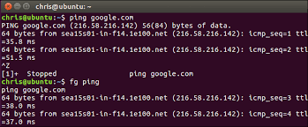

Bash –version linux command:

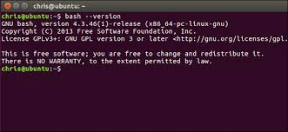

History linux command:

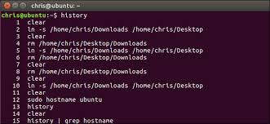

Ls and cat linux command:

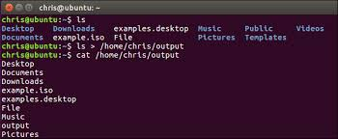

Default=$sp1 linux command:

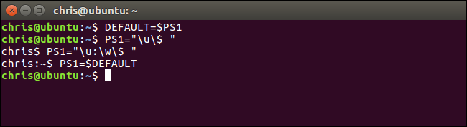

Uname linux command:

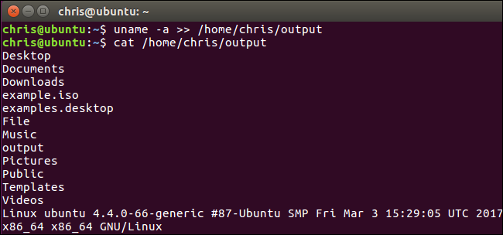

Which zsh and chsh linux commands:

